Smart water fountains

# Pressure sensor and flow sensor:

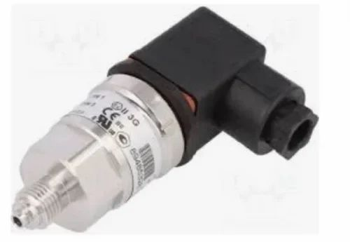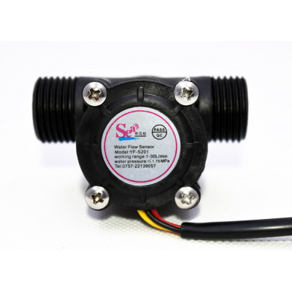

**Pressure sensor:**

**200 Bar TME MAKE PRESSURE SENSOR**

A pressure sensor is an electronic device that measures the force or pressure applied to it, typically by a gas or liquid, and converts this measurement into an electrical signal. It’s used to monitor and control pressure in various applications, from industrial processes to automotive systems.

PM104RT

**Flow sensor:**

A flow sensor, on the other hand, is a device that detects and measures the rate of fluid movement, such as the flow of liquid or gas in a pipe or conduit. It translates the flow rate into an electrical signal and finds applications in industries like HVAC, water management, and medical equipment to ensure proper fluid control and management.

YF-S201

**Data sets:**

Pressure sensor and flow sensor data sets are essential tools in various fields, including engineering, healthcare, and environmental monitoring. These data sets provide valuable insights into the dynamic nature of systems and processes. Pressure sensors record the force applied to a specific area, offering information about liquid or gas pressure within a system. Flow sensors, on the other hand, capture data on the rate of fluid movement, such as the flow of water in a pipe. When combined, these data sets can be used to optimize processes, diagnose issues, and enhance efficiency in numerous applications, from industrial automation to medical devices. Analyzing these data sets can lead to improved performance, reduced energy consumption, and more precise control of syste

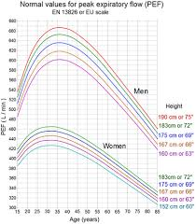

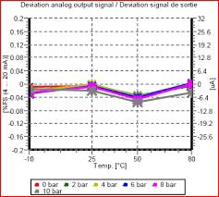

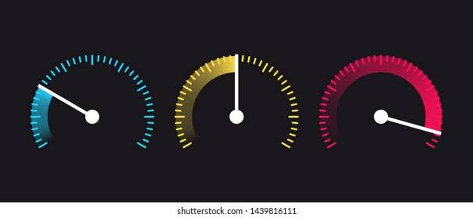**Conclusion:**

Flow sensors and pressure sensors are critical components in various fields due to their ability to monitor and control fluid dynamics and pressure conditions.

Flow sensors are designed to detect and quantify the flow rate of liquids or gases in pipelines or conduits. They operate on principles like thermal, ultrasonic, or mechanical measurements. For example, thermal flow sensors determine flow by measuring the cooling effect of a flowing fluid on a heated sensor element. These sensors play a vital role in applications ranging from industrial processes to healthcare devices. In industrial settings, they ensure the proper distribution of fluids, optimize energy consumption, and facilitate accurate dosing and mixing. In healthcare, they assist in precise drug delivery and respiratory monitoring.

Pressure sensors, on the other hand, are engineered to gauge the force or pressure exerted by liquids or gases on their surfaces. These sensors can be categorized into various types, including piezoelectric, capacitive, or strain gauge sensors. In the automotive industry, pressure sensors help manage airbag deployment and monitor tire pressure. In environmental monitoring, they measure atmospheric pressure for weather forecasting. Pressure sensors are also crucial in healthcare, where they aid in blood pressure measurement and ensure the proper functioning of medical equipment.

Both flow sensors and pressure sensors contribute to enhanced efficiency, safety, and control in a wide array of applications, making them indispensable tools in modern technology and industry.